**KOMBINASI B :**

**Essay (100 %)**

1. **Intermediate code (Bobot 25 Poin)**

Diketahui Statement sbb :

A = A - B / C + (B - C) + C * D

Buatlah :

1. **DAG (10 poin)**

**Jawaban:**

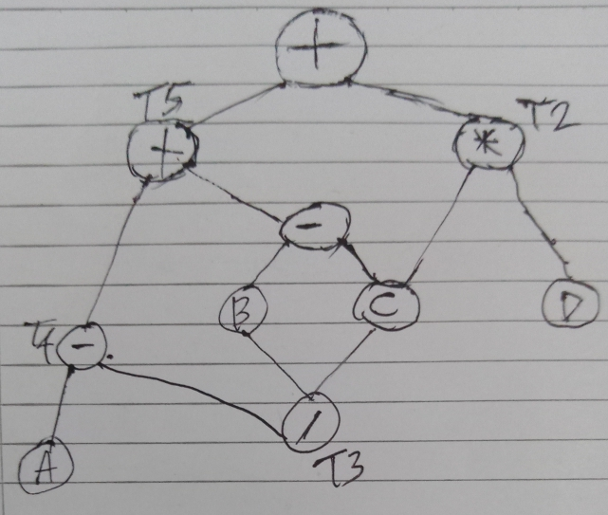

1. **Three Address Code (5 poin)**

**Jawaban:**

T1 = B - C

T2 = C * D

T3 = B / C

T4 = A - T3

T5 = T4 + T1

A = T5 + T2

1. **Quadruples (5 poin)**

**Jawaban:**

|  |  |  |  |  |
| --- | --- | --- | --- | --- |
|  | **OP** | **ARG_1** | **ARG_2** | **RESULT** |
| **(0)** | - | B | C | T1 |
| **(1)** | * | C | D | T2 |
| **(2)** | / | B | C | T3 |
| **(3)** | - | A | T3 | T4 |
| **(4)** | + | T4 | T1 | T5 |
| **(5)** | + | T5 | T2 | A |

1. **Triples (5 poin)**

**Jawaban:**

|  |  |  |  |
| --- | --- | --- | --- |
|  | **OP** | **ARG_1** | **ARG_2** |
| **(0)** | - | B | C |
| **(1)** | * | C | D |
| **(2)** | / | B | C |
| **(3)** | - | A | (2) |
| **(4)** | + | (3) | (0) |
| **(5)** | + | (4) | (1) |

1. Diketahui produksi sbb :

A 🡪 B | A - C

B 🡪 C | bDe

C 🡪 f | A + C

D 🡪 (A)

1. **Buatlah diagram transisi Go To (10 Poin)**

**Jawaban:**

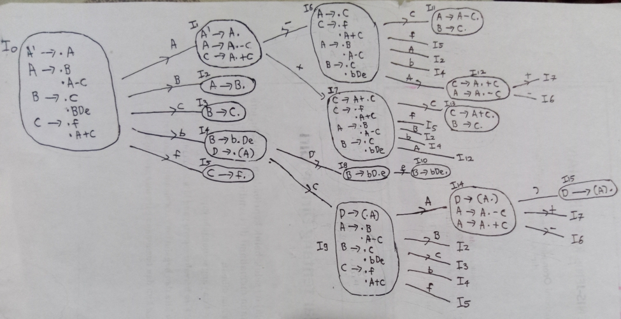

1. **Buatlah SLR table-nya (10 poin)**

**Jawaban:**

|  |  |  |  |
| --- | --- | --- | --- |
| **SLR TABLE** | | | |
| **Goto** | **Kernel** | **State** | **Closure** |
|  | {A' -> .A} | 0 | {A' -> .A; A-> .B; A -> .A - C; B -> .C; B -> .b D e; C -> .f; C -> .A + C} |
| goto(0, A) | {A' -> A.; A -> A.- C; C -> A.+ C} | 1 | {A' -> A.; A -> A.- C; C -> A.+ C} |
| goto(0, B) | {A -> B.} | 2 | {A -> B.} |
| goto(0, C) | {B -> C.} | 3 | {B -> C.} |
| goto(0, b) | {B -> b.D e} | 4 | {B -> b.D e; D -> .( A ) } |
| goto(0, f) | {c -> f.} | 5 | {C -> f.} |
| goto(1, -) | {A -> A -.C} | 6 | {A -> A -.C; C -> .f; C -> .A + C; A -> .B; A -> .A - C; B -> .C; B -> .b D e} |
| goto(1, +) | {A -> A +.C} | 7 | {A -> A +.C; C -> .f; C -> .A + C; A -> .B; A -> .A - C; B -> .C; B -> .b D e} |
| goto(4, D) | {B -> b D.e} | 8 | {B -> b D.e} |
| goto(4, () | {D -> (.A) } | 9 | {D -> (.A ); A -> .B; A -> .A - C; B -> .C; B -> .b D e; C -> .f; C -> .A + C} |
| goto(6, C) | {A -> A - C.; B -> C.} | 10 | {A -> A - C.; B -> C.} |
| goto(6, f) | {C -> f.} | 5 |  |
| goto(6, A) | {C -> A.+ C; A -> A.- C} | 11 | {C -> A.+ C; A -> A.- C} |
| goto(6, B) | {A -> B.} | 2 |  |
| goto(6, b) | {B -> b.D e} | 4 |  |
| goto(7, C) | {C -> A + C.; B -> C.} | 12 | {C -> A + C.; B -> C.} |
| goto(7, f) | {c -> f.} | 5 |  |
| goto(7, A) | {C -> A.+ C; A -> A.- C} | 11 |  |
| goto(7, B) | {A -> B.} | 2 |  |
| goto(7, b) | {B -> b.D e} | 4 |  |
| goto(8, e) | {B -> b D e.} | 13 | {B -> b D e.} |
| goto(9, A) | {D -> ( A.); A -> A.- C; C -> A.+ C} | 14 | {D -> ( A.); A -> A.- C; C -> A.+ C} |
| goto(9, B) | {A -> B.} | 2 |  |
| goto(9, C) | {B -> C.} | 3 |  |
| goto(9, b) | {B -> b.D e} | 4 |  |
| goto(9, f) | {c -> f.} | 5 |  |
| goto(11,+) | {A -> A +.C} | 7 |  |
| goto(11, -) | {A -> A -.C} | 6 |  |
| goto(14, )) | {D -> ( A ) . } | 15 | {D -> ( A ) . } |
| goto(14, -) | {A -> A -.C} | 6 |  |
| goto(14,+) | {A -> A +.C} | 7 |  |

1. **Lakukan stack implementation untuk string : b ( f ) e - f (10 poin)**

**Jawaban:**

|  |  |  |  |
| --- | --- | --- | --- |
| **Step** | **Stack** | **Input** | **Action** |
| 1 | **0** | b ( f ) e - f $ | s**4** |
| 2 | **0** b **4** | ( f ) e - f $ | s**9** |
| 3 | **0** b **4** ( **9** | f ) e - f $ | s**5** |
| 4 | **0** b **4** ( **9** f **5** | ) e - f $ | r**5** |
| 5 | **0** b **4** ( **9** C | ) e - f $ | **3** |
| 6 | **0** b **4** ( **9** C **3** | ) e - f $ | r**3** |
| 7 | **0** b **4** ( **9** B | ) e - f $ | **2** |
| 8 | **0** b **4** ( **9** B **2** | ) e - f $ | r**1** |
| 9 | **0** b **4** ( **9** A | ) e - f $ | **14** |
| 10 | **0** b **4** ( **9** A **14** | ) e - f $ | s**15** |
| 11 | **0** b **4** ( **9** A **14** ) **15** | e - f $ | r**7** |
| 12 | **0** b **4** D | e - f $ | **8** |
| 13 | **0** b **4** D **8** | e - f $ | s**13** |
| 14 | **0** b **4** D **8** e **13** | - f $ | r**4** |
| 15 | **0** B | - f $ | **2** |
| 16 | **0** B **2** | - f $ | r**1** |
| 17 | **0** A | - f $ | **1** |
| 18 | **0** A **1** | - f $ | s**6** |
| 19 | **0** A **1** - **6** | f $ | s**5** |
| 20 | **0** A **1** - **6** f **5** | $ | r**5** |
| 21 | **0** A **1** - **6** C | $ | **10** |
| 22 | **0** A **1** - **6** C **10** | $ | r**2** |
| 23 | **0** A | $ | **1** |
| 24 | **0** A **1** | $ | **ACC** |

1. **(20 Poin) Buatlah annotated parse tree untuk string : 4, 2, 6, 3, 8 +**

**Dan berapa hasil dari S.value ?**

Gunakan Syntax Directed Translation berikut :

|  |  |
| --- | --- |
| Production | Semantic Rules |
| S 🡪 A Sign | S.val = A.val; |
| A.sign = Sign.sign; |
| print(A.val); |
| Sign 🡪 + | Sign.sign=1 |
| Sign 🡪 - | Sign.sign=0 |
| A 🡪 n | A.val = value(n) |
| A 🡪 A1,n | A1.sign=A.sign; |
| if(A.sign = 1) then |
| A.val = max (A1.val,value(n)); |
| else |
| A.val = min (A1.val,value(n)); |

**Jawaban:**

**Therefore, S.value = 8**

1. (25 Poin) Diketahui penggalan program sbb :

**Buatlah code generator untuk penggalan program di atas.**

**Jawaban:**

main:

push rbp

mov rbp, rsp

mov DWORD PTR [rbp-4], 10

mov DWORD PTR [rbp-8], 4

mov DWORD PTR [rbp-12], 6

.L2:

sub DWORD PTR [rbp-4], 1

sub DWORD PTR [rbp-8], 2

mov eax, DWORD PTR [rbp-4]

and eax, 1

test eax, eax

je .L2

cmp DWORD PTR [rbp-4], 9

jle .L3

mov eax, DWORD PTR [rbp-12]

add eax, 4

mov DWORD PTR [rbp-8], eax

jmp .L4

.L3:

add DWORD PTR [rbp-8], 2

sub DWORD PTR [rbp-4], 1

.L4:

cmp DWORD PTR [rbp-8], 9

jle .L2

nop

nop

pop rbp

ret